**What & Why?**

The fields of Additive Manufacturing, or 3D Printing, and Machine Learning have made major advancements in both capabilities and efficiency. More specifically, the integration of AI and Machine Learning in the field of 3D print fabrication has enhanced different stages of the

overall process.

Optimization in part / model design, preparation and simulation of 3D models for fabrication, Closed loop systems and real time monitoring, and Advanced Post-Processing / Analysis are some of the areas that benefit from AI integration and can be pushed even further to continue optimizing and streamlining the Additive Manufacturing process.

## **Research Question**

### Feasibility of Machine Learning for Voice-to-Part 3D Printing

Question: Is it possible to apply machine learning to develop a model that can successfully model and prepare a part for 3D printing, using only a human voice prompt?

Objective: To explore the feasibility and practical implementation of a machine learning model that can take a voice prompt, convert it into a 3D model, and prepare it for 3D printing.

## **Real-Life Application**

### Impact on Product and Industrial Design

A voice-to-part model would revolutionize product and industrial design by:

1. Reducing Design Time: Eliminating the need for manual CAD design, thus accelerating the design iteration process.
2. Increasing Accessibility: Enabling designers with physical disabilities to create parts using voice commands, fostering inclusivity and diversity in the field.

## **Methodology**

### Achieving Voice-to-Part 3D Printing

To achieve this goal, we need to address four major milestones. This thesis focuses on the first two milestones:

1. Text-to-Part Conversion:

#### Milestone 1: Voice-to-Text Conversion

Objective: Train a model to accurately interpret speech prompts and convert them into text.

Requirements: Speech recognition and Natural Language Understanding (NLP) libraries, primarily in English.

Process:

* Data Collection: Gather a dataset of voice commands related to 3D modeling and printing.
* Model Training: Use NLP libraries (e.g., Google's Speech-to-Text, CMU Sphinx) to train a model that can accurately convert voice commands to text.
* Evaluation: Test the model's accuracy in converting voice commands into correct text prompts.

Challenges:

* Speech Variability: Accurately interpreting different accents, tones, and speech patterns.
* Context Understanding: Ensuring the model understands the context of commands related to 3D modeling.

#### Milestone 2: Text-to-Part Conversion

Objective: Develop a model to convert text prompts into 3D models.

Requirements: Training on geometry and design terms, utilizing tools like ComfyUI for 3D model generation.

Process:

* Data Collection: Compile a dataset of text prompts and corresponding 3D models.
* Model Training: Use machine learning techniques to train a model that can generate 3D models from text descriptions.
* Integration with ComfyUI: Leverage ComfyUI's capabilities to assist in 3D model generation based on text inputs.
* Evaluation: Assess the accuracy and quality of generated 3D models.

Challenges:

* Complexity of Commands: Handling complex design commands and ensuring accurate model generation.
* Design Variability: Accounting for different design styles and specifications.

#### Future Milestones (Beyond Thesis Scope)

Milestone 3: Slice Part for 3D Print

Objective: Prepare the generated 3D model for printing.

Requirements: Integration with slicing software (e.g., Bambu, Slic3r, or Cura) to generate necessary production files (g.code and/or 3mf files).

Process:

* Integration: Develop APIs to connect the generated 3D models with slicing software.
* Automation: Automate the slicing process to generate print-ready files.
* Evaluation: Test the accuracy and efficiency of the slicing process.

Challenges:

* Software Compatibility: Ensuring compatibility with various slicing software.
* Optimization: Optimizing slicing parameters for different types of 3D printers and materials.

Milestone 4: Send/Start Print

Objective: Upload the prepared files to the 3D printer and initiate the printing process.

Requirements: Use REST APIs like OctoPrint to communicate with the printer.

Process:

* Integration: Connect the system with 3D printers via REST APIs like OctoPrint.
* Automation: Automate the file upload and printing initiation process.
* Evaluation: Ensure reliable and error-free communication with 3D printers.

Challenges:

* Printer Compatibility: Supporting a wide range of 3D printers.
* Error Handling: Developing robust error handling mechanisms to address printing issues.

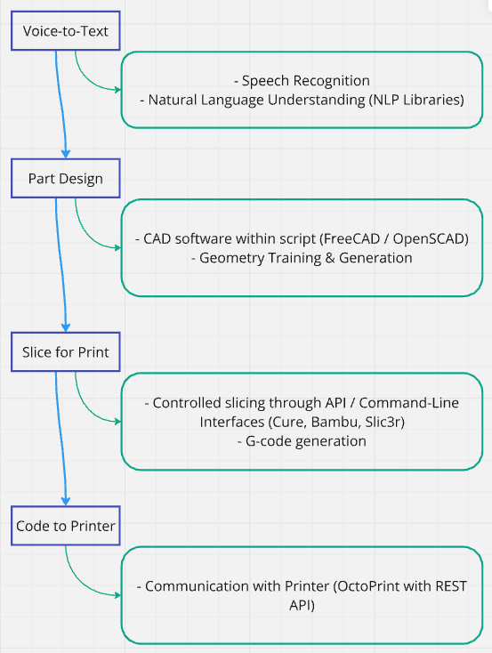

**Deployment:**

Successfully deploying a model after creation will take several infrastructure / pipeline creations, detailed below. After deployment, maintenance will be required via monitoring, user support and regular updates to ensure the model stays running correctly. Finally, feedback loops gathering user experiences and issues will allow for improvement after an initial deployment.

* **Infrastructure Setup:** Choose a cloud provider (AWS, Google Cloud, Azure), set up databases and storage.
* **CI/CD Pipeline:** Automate testing and deployment with CI/CD pipelines.
* **Scaling:** Implement load balancing and auto-scaling.
* **Security:** Implement authentication, data encryption, and regular security audits.

**Maintenance**

* **Monitoring and Logging:** Use tools like Prometheus and Grafana for system monitoring and logging.
* **User Support:** Set up a help desk and provide documentation.
* **Updates:** Regularly fix bugs and add new features.

#### **Deployment Workflow**

* **Initial Deployment:** Deploy to a staging environment, then to production after final testing.
* **Rollout:** Start with a beta release to gather feedback before a full release.

#### **Feedback Loop**

* **Continuous Improvement:** Gather user feedback, prioritize issues, and implement suggestions.

### **Example Tools and Technologies**

* **Voice Recognition:** Google Cloud Speech-to-Text, Amazon Transcribe
* **NLP:** OpenAI GPT-4, Hugging Face Transformers
* **3D Model Generation:** Custom ML models, Blender
* **Slicing Software:** Cura, Slic3r
* **Printer Communication:** OctoPrint
* **Infrastructure:** AWS, Google Cloud, Azure
* **CI/CD:** Jenkins, GitHub Actions, GitLab CI
* **Monitoring:** Prometheus, Grafana
* **User Support:** Zendesk, Freshdesk

**Precedents Links:**

# BrepGen: A B-rep Generative Diffusion Model with Structured Latent Geometry

* 1. <https://arxiv.org/abs/2401.15563>

1. Voice-to-Model-to-Print
   1. <https://www.instagram.com/reel/C7F5kcJSXeT/?igsh=bDQ2Z2VnM3FzcWRnb> “dictated to ChatGPT, which sent a Python command to Bambu
2. MX3D Bridge - Generative Design / 3D Printed Bridge
   1. <https://mx3d.com/industries/mx3d-bridge/>
3. Voice2Mesh
   1. <https://arxiv.org/abs/2104.10299>
4. Gesture and SPeech elicitation for 3D CAD Modeling
   1. https://www.sciencedirect.com/science/article/abs/pii/S0926580517306106